RESOLUTION NO.__________

RE: CERTIFICATE OF APPROPRIATENESS UNDER THE
PROVISIONS OF THE ACT OF THE PENNSYLVANIA
LEGISLATURE 1961, JUNE 13, P.L. 282 (53
SECTION 8004) AND BETHLEHEM ORDINANCE NO.
3952 AS AMENDED.

WHEREAS, it is proposed to replace the four ground floor windows at
452 N. New St.

NOW, THEREFORE, BE IT RESOLVED by the Council of the City of Bethlehem that a Certificate of Appropriateness is hereby granted for the proposal.

Sponsored by: (s)

(s)

ADOPTED BY COUNCIL THIS DAY OF

(s)
President of Council

ATTEST:

(s)
City Clerk

HISTORICAL & ARCHITECTURAL REVIEW BOARD

APPLICATION #2: The applicant proposes to replace the ground floor windows at
452 N. New St.

OWNER: Paul & Sharon Schmitt
452 N. New St., Bethlehem, PA 18018
__________________________________________________________________

The Board upon motion by Connie Glagola and seconded by Marsha Fritz adopted the proposal that City Council issue a Certificate of Appropriateness for the following:

- The required replacement of four ground floor windows with Marvin Ultimate Clad Windows.

2. The motion was unanimously approved.

__________________________________________________________________________

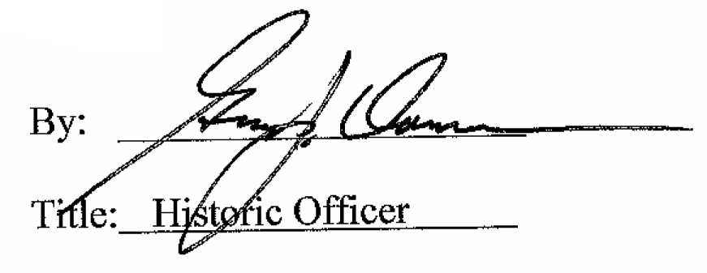

Date of Meeting: January 7, 2015

